RESOLUTION NO.__________

RE: CERTIFICATE OF APPROPRIATENESS UNDER THE
PROVISIONS OF THE ACT OF THE PENNSYLVANIA
LEGISLATURE 1961, JUNE 13, P.L. 282 (53
SECTION 8004) AND BETHLEHEM ORDINANCE NO.
3952 AS AMENDED.

WHEREAS, it is proposed to add window cling signage of the business logo on the inside of the storefront window at 324 South New Street.

NOW, THEREFORE, BE IT RESOLVED by the Council of the City of Bethlehem that a Certificate of Appropriateness is hereby granted for the proposal.

Sponsored by: (s)

(s)

ADOPTED BY COUNCIL THIS DAY OF

(s)
President of Council

ATTEST:

(s)
City Clerk

HISTORIC CONSERVATION COMMISSION

CASE #639 -- It is proposed to add window cling signage of the business logo on the inside surface of the storefront window at 324 South New Street.
OWNER/APPLICANT: Bethlehem Parking Authority/Missy Hartney

The Commission upon motion by Mr. Hudak and seconded by Mr. Lousch adopted the proposal that City Council issue a Certificate of Appropriateness for the proposed work described herein:

- The proposal to install new cling signage of the business logo on the inside surface of the storefront window at 324 South New Street was presented by Missy Hartney.
- The proposed cling signage is approximately 70” tall x 45” wide and designed to fill the entire glass surface of the street-level window next to the entrance door within the framed storefront assembly. The signage includes the SouthSide Arts District organizational name (large, white contemporary lettering in several fonts) and logo (white silhouettes of industrial structures framed by a thick white border and multi-colored background); the name and logo are designed to contrast with the perforated matte black background.
- The motion for the proposed work was approved 5-3.

JBL: jbl
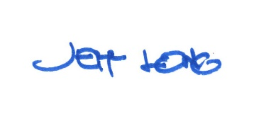

By:

Date of Meeting: February 26, 2018 Title: Historic Officer

